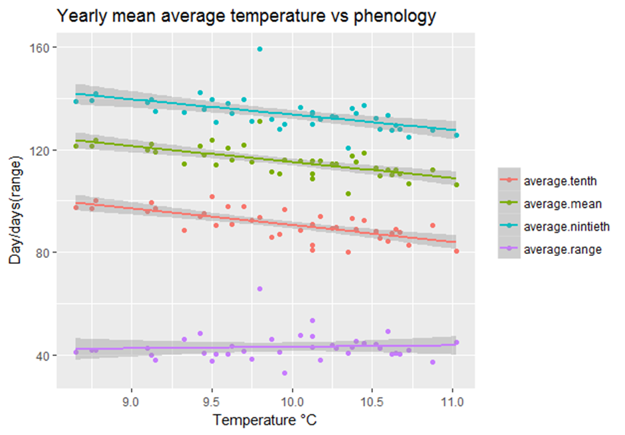

* Warmer years result in earlier flight dates, mean times and end dates.
* Temperature has no effect on flight period length.

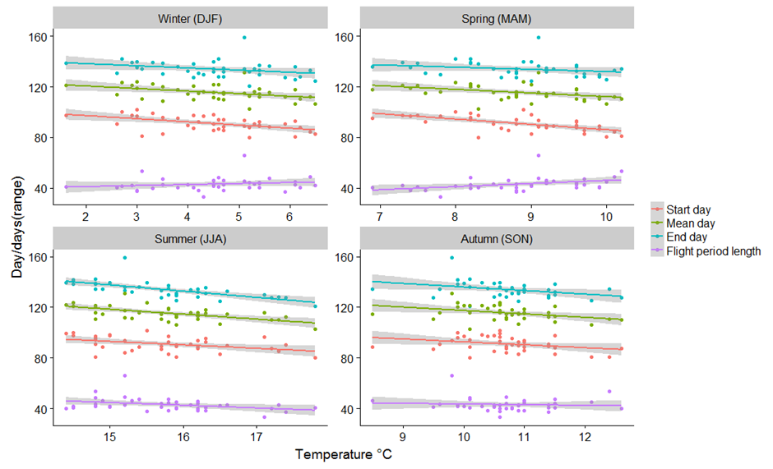

|  |  |  |  |  |  |  |  |
| --- | --- | --- | --- | --- | --- | --- | --- |
| Season | Phenology | Intercept | Gradient | P value | F stat | R2 | Adjusted R2 |
| Year | Start day | 155.85 | -6.529 | >0.001 | 36.99 | 0.5 | 0.4864 |
|  | End day | 193.11 | -5.951 | >0.001 | 17.74 | 0.3241 | 0.3059 |
|  | Mean day | 177.362 | -6.224 | >0.001 | 31.76 | 0.4619 | 0.4473 |
|  | Range | 37.261 | 0.578 | 0.6834 | 0.169 | 0.004546 | -0.02236 |
| Season | Phenology | Intercept | Gradient | P value | F stat | R2 | Adjusted R2 |
| Spring | Start day | 128.17 | -4.22 | >0.001 | 23.3 | 0.3864 | 0.3698 |
| Summer | Start day | 134.39 | -2.76 | 0.00768 | 7.95 | 0.1769 | 0.1546 |
| Autumn | Start day | 115.65 | -2.3 | 0.04678 | 4.232 | 0.1026 | 0.07838 |
| Winter | Start day | 102.17 | -2.5 | >0.001 | 13.41 | 0.2661 | 0.2462 |
|  |  |  |  |  |  |  |  |
| Spring | End day | 147.37 | -1.75 | >0.001 | 2.024 | 0.05188 | 0.02625 |
| Summer | End day | 211.49 | -4.93 | >0.001 | 28.98 | 0.4392 | 0.4241 |
| Autumn | End day | 164.26 | -2.83 | 0.03043 | 5.066 | 0.1204 | 0.09665 |
| Winter | End day | 141.6 | -1.71 | 0.05408 | 3.958 | 0.09664 | 0.07222 |
|  |  |  |  |  |  |  |  |
| Spring | Mean day | 141 | -2.89 | 0.00633 | 8.38 | 0.1847 | 0.1626 |
| Summer | Mean day | 176.95 | -3.91 | >0.001 | 20.78 | 0.3596 | 0.3423 |
| Autumn | Mean day | 144.65 | -2.725 | 0.01667 | 6.289 | 0.1453 | 0.1222 |
| Winter | Mean day | 124.59 | -2.03 | 0.00746 | 8.016 | 0.1781 | 0.1558 |
|  |  |  |  |  |  |  |  |
| Spring | Range | 21.2 | 2.47 | 0.01363 | 6.71 | 0.1535 | 0.1306 |
| Summer | Range | 77.1 | -2.17 | 0.02652 | 5.34 | 0.1261 | 0.1025 |
| Autumn | Range | 48.61 | -0.52 | 0.6366 | 0.2269 | 0.006096 | -0.02077 |
| Winter | Range | 39.43 | 0.8 | 0.2823 | 1.19 | 0.03117 | 0.004985 |

* Start date variation is most explained by spring (39%) and winter temperatures (27%)
  + Warmer temperatures result in earlier start dates.
    - Larvae develop faster?
* End day variation is most explained by summer temperature (44%).
  + Warmer temperatures result in earlier end dates.
    - Life cycle faster?
* Mean day variation most explained by summer temperature (36%).
  + Warmer temperatures result in earlier mean flight days.
* Spring and summer are the only seasons to have a significant impact on flight period length.

|  |  |  |  |  |  |
| --- | --- | --- | --- | --- | --- |
|  | Phenology | P value | F stat | R2 | Adjusted R2 |
| Difference temperature | Mean day | >0.001 | 15.48 | 0.295 | 0.2759 |

Hot springs followed by cool summers result in longer flight periods.

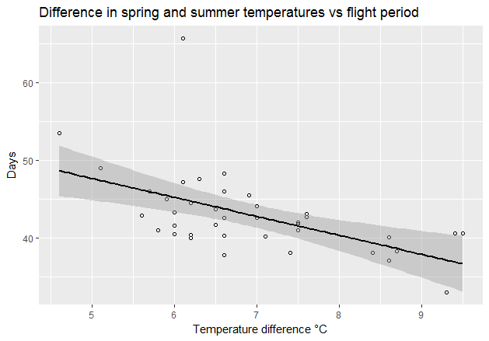

Brakefield (1987) found that 95% of variation in mean flight dates in *M.jurtina* explained by June maximum. Found cooler summers result in later mean.

http://onlinelibrary.wiley.com/doi/10.1111/j.1365-2311.1987.tb00993.x/abstract

|  |  |  |  |  |  |
| --- | --- | --- | --- | --- | --- |
|  | Phenology | P value | F stat | R2 | Adjusted R2 |
| June Max | Mean day | >0.001 | 43.96 | 0.543 | 0.5306 |

Results show only 54% of variation explained by June maximum.

